**Documentation to demonstrate the functionality of the RTS125+ in a flight situation**

The photo belows shows the RTS125+ used for in-flight measurements by the Canadian Transportation Agency. You can see the RTS125+ interrogator on the bottom shelf of the rack assembly.

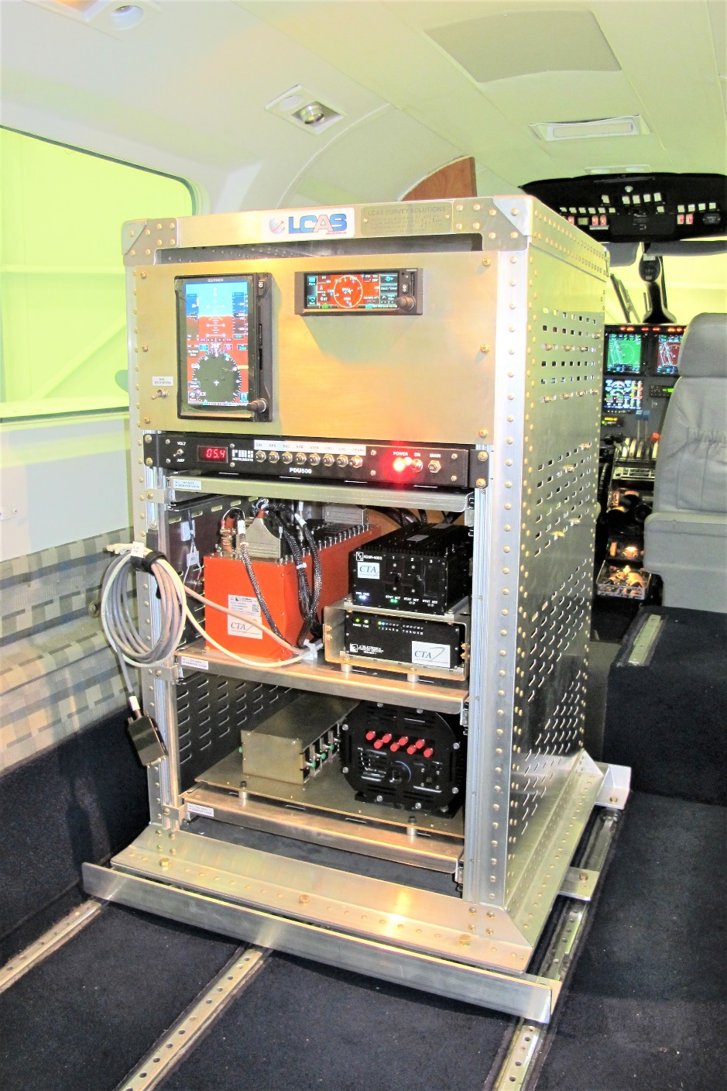

“ Frank Pena and Jonathan Lopez work on securing a Fiber Optic Sensing System unit developed at NASA’s Armstrong Flight Research Center in California. The unit is one of five developed to test a new variant of the technology researchers have developed to withstand the harsh environments of a rocket launch and space travel.

***Credits: NASA Photo / Ken Ulbrich “***

The photo below shows the ruggedized housings to contain the Sensuron RTS125+ internal components.

